Logo%20Main%20200

**Boston University**

**Electrical & Computer Engineering**

**EC463 Capstone Senior Design Project**

**Problem Definition and Requirements Review**

Luminesense



Submitted to

Professor Thomas DC Little

Boston, MA

(617) 353-9877

tdcl@bu.edu

by

Team # 1

Luminesense

Team Members

Caroline Jones [ctjones@bu.edu](mailto:email1@bu.edu)

Michael Haley [mhaley10@bu.edu](mailto:email1@bu.edu)

Sneha Pradhan [snehha@bu.edu](mailto:email1@bu.edu)

Tanatsigwa Hungwe [hungweta@bu.edu](mailto:email1@bu.edu)

Zehua Zhao [zehuaz@bu.edu](mailto:email5@bu.edu)

Submitted: 10th October 2016

**Customer Sign-Off _______________________________________**

#### Adaptive Gesture Based Lighting System

#### Table of Contents

Project Summary

2 Need for this Project

3-4 Problem Statement and Deliverables

5-6 Visualization

7-8 Competing Technologies

9 Engineering Requirements

10-11 Appendix A References.

# 

# 

# Project Summary

Luminesense is aiming to build an energy efficient, adaptive and gesture based lighting system that caters to the needs of all its users. Our main goal is to provide an interaction with the everyday lighting system to take a step further in building a smarter home by saving energy as well as money. We are looking to revolutionize the current lighting system with our new wearable device that will allow the user to interface with the lighting system. The user will be able to do this in two modes - adaptive and gesture based. In the adaptive mode, the system will detect the location of the user and toggle the lights accordingly. In the gesture based mode, the user will be able to control the lights using a gesture language that we will create. Moreover, the user will be able to save their settings in a cloud based server as well as be able to see their energy performance on a web application.

# Need for this Project

As the human population and our energy consumption grow exponentially, clever technological solutions are needed to sustain this growth. Humans are depleting essential resources that can not be easily replenished. Specifically, electricity is one of the main resources being exploited. By leaving lights on in a room that is not in use, the average consumer produces an additional 0.15 pounds of greenhouse gas emissions per hour[1]. Needless to say, lighting systems are everywhere -- from skyscrapers and roadways to residential homes and apartment complexes.

Therefore, the need for energy efficient lighting is crucial. There are energy efficient systems, however they lack the technical “intelligence” many important systems have benefitted from. Lighting system needs to be both energy efficient and convenient for people to use.

Luminesense is aiming to provide technology that solves both problems. In the world of “IoT” ( Internet of Things), lighting hasn’t seen sufficient improvement. Luminesense is attempting to pioneer lighting systems in the “Internet of Things” era.

Our product includes a user-worn device that enables our system to detect numerous hand gestures the user makes, and respond accordingly. We are looking to improve society’s quality of life by providing an intuitive method to interact with a lighting environment while helping everyone save energy resources.

# Problem Statement and Deliverables

We seek to improve upon current lighting systems by integrating adaptive and gesture-based systems into existing lighting solutions. Current systems to detect the presence of persons in a room do not work well - counting and locating people is difficult to achieve in an inexpensive fashion. Our system will provide a state of the art solution to this problem by introducing a wearable that accurately detects and positions the user relative to the luminaires in the room.

Our system provides control not only in a general sense for occupancy, but also in a user-specific way by allowing the user to set preferences for how they prefer a room’s lighting. One user may prefer lights that are dim while another user might prefer bright blue lights. This gives the user control over their environment in an automatic and intuitive fashion that current systems do not allow. Moreover, users might have preferences based on other factors such as time of day, which the systems will also account for. All of these preferences will be stored in the cloud so that the user can access these preferences in other buildings.

Current lighting solutions lack this ability of customization that we will provide. Further customization options include the ability for the user to create their own gesture language. Although the project will include a default gesture language for interacting with the lights, users might choose to save their own preferences. Beyond adding another level of customization to the system, this will also enable people with disabilities to set their own custom gestures so that they can interact fully with the system.

Upon completion of project goals, the team will present to the client the following deliverables:

1. Gesture language: a comprehensive set of gesture-based commands available to the user; which they will use to effectively interact with the system. An accompanying dictionary that describes and explains all possible gestures will be provided.

2. Wearable transceiver: this body-worn device will be used to communicate with the system components (the Raspberry Pi and the Luminaires).

3. Control software: An algorithm designed to accomplish 3 tasks:

* To recognize the location of the user(s) utilizing the wearable device.
* To analyze the information being sent amongst the Raspberry Pi, the Luminaires and the user i.e the gesture and the light codes.
* To control the states of each individual Luminaire within the system.

4. Web application: An interactive interface which allows users to store their lighting preferences on the cloud (via Amazon Web Services).

5. Web server: A web-based solution to monitor, document and report the system's performance over time (energy savings and functionality test results).

6. Video: A demonstrative video exhibiting the product's features and functionality.

7. Report: A tome which details all research, problem-solving methodologies, design choices and considerations made in the span of the project's lifecycle.

# Visualization

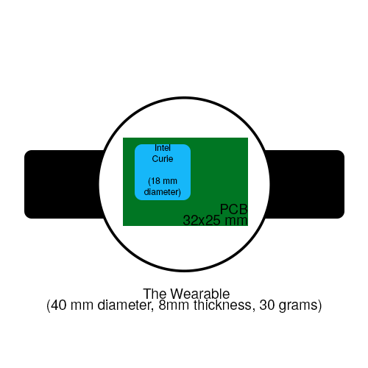

Fig 1. The Wearable. This device is designed to be worn on the wrist like a watch. The Intel Curie chip has a 6-axis combo sensor that works with accelerometers and gyroscopes and communicates with Bluetooth. A PCB board will be designed to contain the chip as well as fit within the dimensions of the wearable. The wearable itself will be made of plastic and an elastic band.

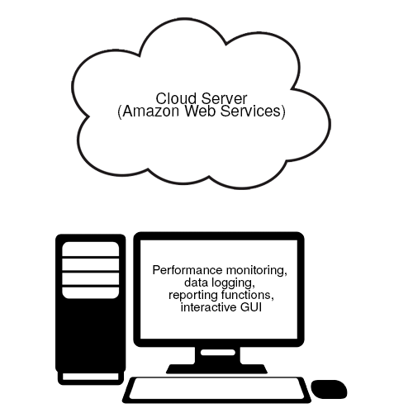

Fig 2. The Cloud Server and User Interface. To store user preferences and energy savings data, a cloud based solution will be employed. Users can interact with these via a GUI, where users can also set more customizable options such as adding administrative users.

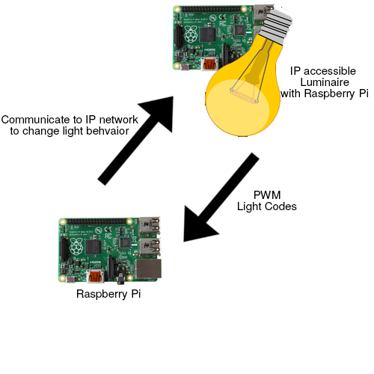

Fig 3. The Luminaires.These Luminaires will be sending unique “light codes” using pulse width modulation in order to distinguish between the lights. The central Raspberry Pi will communicate with each Luminaire over an IP network after the user with the wearable makes a gesture command or a user enters or exits the room.

# Competing Technologies

During the span of the project, it is important to acknowledge any existing competing technologies, patents, and products. Valuable insight can be gained from their project development methodologies and results.

Ubiquilux[2]

A Toronto based company that utilizes gesture technology to control lighting and lighting setups. The technologies involved include Gesture Sense[3] and ActiveSaver[4]. Gesture Sense (created by XYZ Interactive[14]) uses low cost technology to recognize simple gestures (movements away, towards and past the sensors). ActiveSaver adjusts the settings based on the ambient light in the room. Ubiquilux produced the e-Motion[5] dimmer switch: an LED light dimmer with a touchless gesture control interface.

Product requirements and constraints:

• Works in all lighting conditions even bright sunlight

• Gesture hand sensing range up to 12 inches

• Ambient light level sensor adjusts LED indicator brightness automatically

• Warranty: Lifetime Limited

Lutron[6]

A company that specializes in providing energy saving solution for existing homes and offices. Technologies involved include EcoSystem[7] and Caseta Wireless[8]. EcoSystem is a control method that provides addressing of individual LED fixtures. This makes it easy to deliver smooth and continuous dimming across all fixture types (useful for energy-saving, system-monitoring and system-control schemes). Caseta Wireless conveniently controls light systems remotely.

Product requirements and constraints[9][10]:

• 60% power savings

• Remote control dimensions H: 2.60" (66mm) H: 1.28" (33mm) D: 0.33" (8mm)

• Power failure memory: If power is interrupted, the control will return to its previously set level prior to interruption.

• Works with dimmable LEDs and CFLs as well as incandescent and halogen light bulbs.

• Up to ten transmitting devices may be associated to each in-wall dimmer.

• Ambient operating temperature: 32 °F to 104 °F (0 °C to 40 °C). Indoor use only.

MIT[11]

Responsive Environments Group at the MIT Media Lab, collaborated with Philips Color Kinetics[12] to develop polychromatic solid-state lighting fixtures controlled using a sensor network. This was developed with a spectrally tunable light source and an interactive lighting testbed to study the effects of systems that adjust in response to changing environmental lighting conditions and users' requirements of color and intensity.

Product requirements and constraints[13]:

• Lighting network’s power consumption must be minimized by using feedback from the user and environment

• The intensity of the LED fixture is controlled using 16-bit pulse width modulation (PWM)

• The lighting network must be capable of energy efficient operation without the direct intervention and constant adjustment by the user.

• The sensor node must detect intensity and color, feature basic controls for the user, and detect occupancy.

The respective product requirements and constraints described above may not exactly match the engineering requirements for Luminesense. However, they do highlight some of the considerations that need to be made during the design of the Luminesense system.

# Engineering Requirements

There are two main functions built in the project:

1. Adaptive mode

* Identify user with wearable device and modify the lights according to the default settings stored in cloud server.
* Detect user location in room and turn on luminaires at specific locations.

1. Gesture-control mode

* With wearable device and simple gesture language, user can change light intensity, color, and directionality.
* Able to interact with one or more lights in the room.

The objective of this project are as follows:

1. The lighting system will improve energy efficiency of light usage in buildings.
2. The project should be able to integrate into current lighting systems.
3. Create a universal gesture language in order to sell to a global market.
4. Provide a cloud server to store user personal settings which can be accessed by each single room or building.

The constraints that this project must adhere to are as follows:

1. The Wearable must be comfortable and well-fitting for all users and weigh less than 30 grams.
2. The Wearable must be durable enough to allow users to wear all day every day for at least 2 years before a replacement is required.
3. The Wearable cannot cost more than $50 in materials cost, and in quantity should be made for no more than $25 each.
4. The Gesture Language must be easy to understand by users of all ages over age 5.
5. The Gesture Language must at a minimum provide control over turning the lights on and off, dimming the lights, changing the directionality of the lights, and changing the color of the lights.
6. The Gesture Language must be able to be customized by the user and account for a wide range of gestures and motions.
7. The system must adapt to instruction inputs by more than one person in the room without conflict or competition for control over a single luminaire.
8. The lighting systems must recognize a unique individual when they are wearing the wearable and adapt to their user preferences.
9. The system must not present a physical danger to the user in the form of electric shock or otherwise.
10. The system must not reveal more private information about a user than a smartphone would.
11. The system must allow a user without a wearable to have basic control over the lights (on and off).
12. A GUI must be provided as a backup to the gesture language to interact with the lights and save user preferences.

# Appendix A References

[1] Boston University, 2008, “Turn Off The Lights”, from http://www.bu.edu/sustainability/what-you-can-do/ten-sustainable-actions/turn-off-the-lights/

[2] Ubilquilux

"Ubiquilux | EMotion Gesture Control Lighting." *Ubiquilux*. N.p., n.d. Web. 4 Oct. 2016. <<http://www.ubiquilux.com/>>.

[3] Gesture Sense

"GestureSense | Xyz Interactive." *Xyz Interactive*. Rowe+Co, n.d. Web. 4 Oct. 2016. <<http://www.xyzinteractive.com/gesturesense/>>.

[4] ActiveSaver (Requirements and Constraints)

E-Motion Gesture Switch. *E-Motion Sales Sheet*. N.p.: E-Motion Gesture Switch, n.d. *E-Motion Sales Sheet*. Web. <<http://banvil2000.com/images/pdf/catalogs/Specs/e-Motion_Sales_Sheet.pdf>>.

[5] E-Motion (Requirements and Constraints)

E-Motion Gesture Switch. *E-Motion Gesture Switch*. N.p.: E-Motion Gesture Switch, n.d. *E-Motion Spec Sheet*. Web. <<http://media.wix.com/ugd/0adb79_7408d3d762c44b308474126dbad07070.pdf>>

[6] Lutron

"Lutron Electronics, Inc." *Lutron Electronics, Inc. - Dimmers And Lighting Controls*. N.p., n.d. Web. 10 Oct. 2016. <<http://www.lutron.com/en-US/Pages/default.aspx>>.

[7] EcoSystem

"EcoSystem Technology." *Lutron Electronics, Inc. | EcoSystem Technology*. N.p., n.d. Web. 10 Oct. 2016. <<http://www.lutron.com/en-US/Education-Training/Pages/LCE/Technologies/EcoSystem/Features.aspx>>.

[8] Caseta Wireless

"Caseta® Wireless." *Caseta® Wireless – Features*. N.p., n.d. Web. 10 Oct. 2016. <<http://www.lutron.com/en-US/Products/Pages/SingleRoomControls/CasetaWireless/features.aspx>>.

[9] Caseta Requirements

CasétaT Wireless. *CasétaT Wireless In-Wall Dimmer*. N.p.: CasétaT Wireless, n.d. *CasétaT Wireless In-Wall Dimmer Spec*. Web. <<http://www.lutron.com/TechnicalDocumentLibrary/369804b_Caseta%20In-Wall%20Dimmer%20Spec.pdf>>.

[10] EcoSystem Requirements

*Lutron Electronics, Inc* | EcoSystem Technology. *EcoSystem Technology Design Guide*. N.p.: Lutron Inc | EcoSystem Technology, n.d. *EcoSystem Technology*. Web. <http://www.lutron.com/technicaldocumentlibrary/ecosystem_design_guide.pdf>.

[11] MIT

"MIT - Energy Efficient Control of Polychromatic Solid State Lighting." *Conference Proceedings*. N.p., n.d. Web. 10 Oct. 2016. <<http://proceedings.spiedigitallibrary.org/proceeding.aspx?articleid=754196>>.

[12] Philips Color Kinetics

"Philips Color Kinetics." *Philips Color Kinetics - LED Lighting Systems, LED Lights*. N.p., n.d. Web. 10 Oct. 2016. <<http://www.colorkinetics.com/>>.

[13] Responsive Environments Group (MIT Media Lab Research Team)

[Matthew Aldrich](http://profiles.spiedigitallibrary.org/summary.aspx?DOI=10.1117%2f12.860755&Name=Matthew+Aldrich) [; Nan Zhao](http://profiles.spiedigitallibrary.org/summary.aspx?DOI=10.1117%2f12.860755&Name=Nan+Zhao) [and Joseph Paradiso](http://profiles.spiedigitallibrary.org/summary.aspx?DOI=10.1117%2f12.860755&Name=Joseph+Paradiso)

"Energy efficient control of polychromatic solid state lighting using a sensor network", *Proc. SPIE* 7784, Tenth International Conference on Solid State Lighting, 778408 (August 18, 2010); doi:10.1117/12.860755;<http://dx.doi.org/10.1117/12.860755>

[14] XYZ Interactive (one of the founding companies behind Gesture Sense and Ubiquilux)

"Xyz Interactive | Sensible Technology." *Xyz Interactive*. Rowe+Co, n.d. Web. 10 Oct. 2016. <http://www.xyzinteractive.com/>.